Hydra – Multi adapter for MSX

About
Hydra is a multi controller adapter for MSX. It provides connection with wired controllers from several video games:

- Nintendo
- NES
- SNES
- Nintendo 64
- Gamecube
- Wii Nunchuck
- SEGA
- Master System
- Genesis 3 button
- Genesis 6 button
- SONY
- Digital (PSONE)
- Dualshock
- Guitar

It also provides interface to a ps/2 mouse in three operation modes:
- Standard Mouse
- Mouse + Joystick emulation
- Joystick emulation

Additional features:
- Auto detection on startup
- OLED display for status

Project Description
The circuit is built upon an ATMega328, a shift register, an OLED display and some cable adapters. The microcontroller runs a firmware developed upon Arduino environment using a bunch of third party libraries .

BLOCK DIAGRAM
The circuit consists of an Arduino board with a CD4021 shift register.

Arduino
shift
register
select

SEGA
GENESIS
latch

clock

cmd

data

NES/
SNES
data

clock

latch

UP

DOWN

LEFT

RIGHT

B/A

C/START

clock

att

DUALSHOCK
/ GUITAR
data

ack

N64/
GAMECUBE
1 wire

UP

DOWN

LEFT

RIGHT

B/A

C/START

MSX
PULSE

NUNCHUCK
SDA

SCL

Display
SDA

SCL

Debug

Serial
INT0
PORT
B
EEPROM
64Kx8
SDA

SCL

ARDUINO PIN USAGE
The circuit uses most of the pins of the Arduino yet the TXD line is kept free to add debug capacity.
Arduino/AVR | MSX | MOUSE | Display | WII | Dualshock | Genesis | NES/SNES | N64 | Gamecube
0 / PD0 |  |  |  |  |  |  |  | 1wire
1 / PD1
2 / PD2 | PULSE
3 / PD3 |  |  |  |  | ATT | LATCH | LATCH
4 / PD4 |  |  |  |  | CLOCK | CLOCK | CLOCK
5 / PD5 |  |  |  |  | CMD | SELECT
6 / PD6 |  |  |  |  | DATA
7 / PD7 |  |  |  |  |  |  |  |  | 1 wire
8 / PB0 | UP
9 / PB1 | DOWN
10 / PB2 | LEFT
11 / PB3 | RIGHT
12 / PB4 | TRGA
13/ PB5 | TRGB
(14)A0 / PC0 |  |  |  |  |  | DATA
(15)A1 / PC1 |  |  |  |  |  |  | DATA
(16)A2 / PC2 |  | DAT
(17)A3 / PC3 |  | CLK
(18)A4 / PC4 |  |  | SCL | SCL
(19)A5 / PC5 |  |  | SDA | SDA

CONNECTOR PINOUT

MSX Side – DE-9
DE-9 | MSX | Direction
1 | UP | OUT
2 | DOWN | OUT
3 | LEFT | OUT
4 | RIGHT | OUT
5 | +5V | POWER
6 | TRG A | OUT
7 | TRG B | OUT
8 | PULSE | IN
9 | GND | POWER

Controllers Side DB-25

DB-25 | Function | Direction
1 | +5V
2
3
4
5
6
7
8
9
10
11
12
13 | +3V3
14 | GND
15
16
17
18
19
20
21
22
23
24
25 | GND

Buttons and controls Assignment
The buttons and digital controls have been mapped to MSX joystick buttons or button combinations. The analog controls have been mapped to equivalent directional controls but are available as paddles and are accessible through Basic

Sega Master System (SMS)
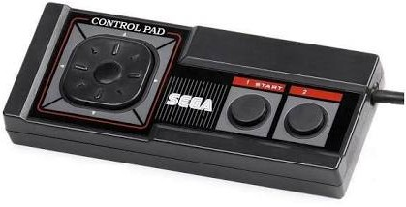  SMS | MSX
UP | UP
DOWN | DOWN
LEFT | LEFT
RIGHT | RIGHT
BT1 | TRG A
BT2 | TRG B

Sega Genesis 3 button
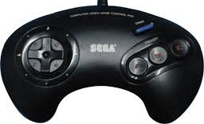  Sega 3B | MSX
UP | UP
DOWN | DOWN
LEFT | LEFT
RIGHT | RIGHT
A | TRG A
B | TRG B
C | TRG A+B
START | LEFT+RIGHT

Sega Genesis 6 button
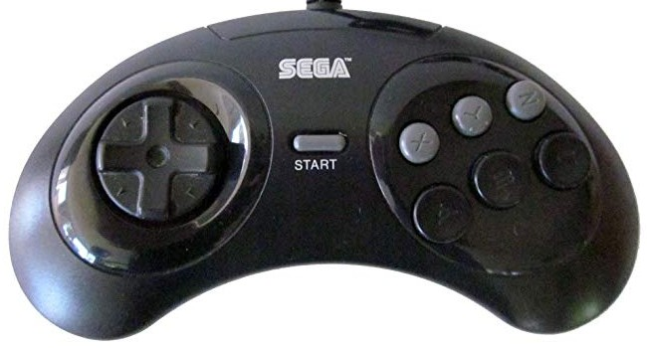  Sega 6B | MSX
UP | UP
DOWN | DOWN
LEFT | LEFT
RIGHT | RIGHT
A | TRG A
B | TRG B
C | TRG A+B
X | TRG A Autofire
Y | TRG B Autofire
Z | TRG A+B Autofire
START | LEFT+RIGHT
MODE | UP+DOWN

NES
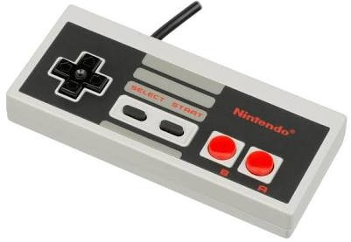  NES | MSX
UP | UP
DOWN | DOWN
LEFT | LEFT
RIGHT | RIGHT
A | TRG A
B | TRG B
START | LEFT+RIGHT
SELECT | UP+DOWN

Super NES
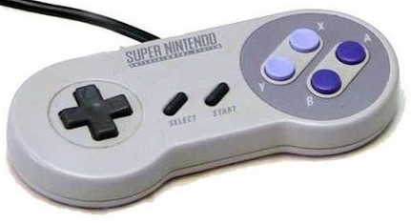  SNES | MSX
UP | UP
DOWN | DOWN
LEFT | LEFT
RIGHT | RIGHT
A | TRG A
B | TRG B
X | TRG A Autofire
Y | TRG B Autofire
L | UP + LEFT
R | UP + RIGHT
START | LEFT+RIGHT
SELECT | UP+DOWN

Nintendo 64
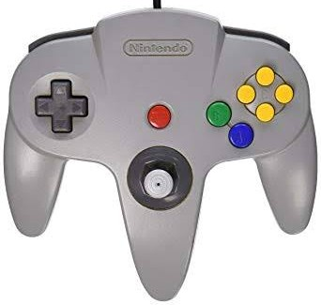  N64 | MSX
D-UP | UP
D-DOWN | DOWN
D-LEFT | LEFT
D-RIGHT | RIGHT
A | TRG A
B | TRG B
Z | TRG A Autofire
L | UP + LEFT
R | UP + RIGHT
START | LEFT+RIGHT
C-UP | TRG A+UP
C-DOWN | TRG A+DOWN
C-LEFT | TRG A+LEFT
C-RIGHT | TRG A+RIGHT
X axis | PDL(5)[/6]
Y axis | PDL(1)[/2]
X Axis(*) | LEFT/RIGHT
Y Axis(*) | UP/DOWN
(*) Digital equivalent

WII Nunchuck
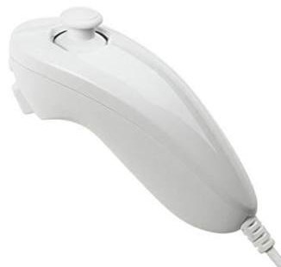  N64 | MSX
C | TRG A
Z | TRG B
X Axis(*) | LEFT/RIGHT
Y Axis(*) | UP/DOWN
X axis | PDL(5)[/6]
Y axis | PDL(1)[/2]
Accel X | PDL(7)[/8]
Accel Y | PDL(3)[/4]
Acell Z | PDL(9)[/10]
(*) Digital equivalent

Gamecube
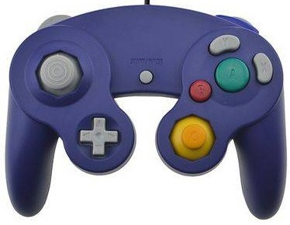  N64 | MSX
D-UP | UP
D-DOWN | DOWN
D-LEFT | LEFT
D-RIGHT | RIGHT
A | TRG A
B | TRG B
X | TRG B Autofire
Y | UP+DOWN(*)
Z | TRG A Autofire
START | LEFT+RIGHT
L(**) | UP + LEFT
R(**) | UP + RIGHT
C-X axis(**) | TRG A + LEFT/RIGHT
C-Y axis(**) | TRG A + UP/DOWN
D-X axis(**) | LEFT/RIGHT
D-Y axis(**) | UP/DOWN
L | PDL(11)[/12]
R | PDL(9)[/10]
C-X axis | PDL(7)[/8
C-Y axis | PDL(3)[/4]
D-X axis | PDL(5)[/6]
D-Y axis | PDL(1)[/2]
(*) Y mapped as a SELECT button
(**) Digital equivalent

Dualshock
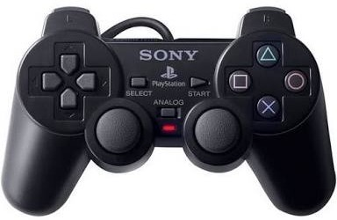  Dualshock | MSX
D-UP | UP
D-DOWN | DOWN
D-LEFT | LEFT
D-RIGHT | RIGHT
Triangle | TRG A Autofire
Square | TRG B Autofire
Cross | TRG A
Ball | TRG B
L1 | UP + LEFT
R1 | UP + RIGHT
L2 | DOWN+LEFT
R2 | DOWN+RIGHT
START | LEFT+RIGHT
SELECT | UP+DOWN
L-X Axis (*) | LEFT/RIGHT
L-Y Axis(*) | UP/DOWN
R-X Axis (*) | TRG A + LEFT/RIGHT
R-Y Axis(*) | TRGA + UP/DOWN
L-X Axis | PDL(5)[/6]
L-Y Axis | PDL(1)[/2]
R-X Axis | PDL(7)[/4]
R-Y Axis | PDL(3)[/8]
L3 | Not assigned
R3 | Not assigned
(*) Digital equivalent

Guitar Hero Controller
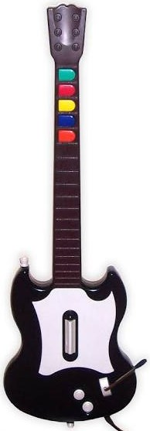  Guitar | MSX
GREEN_FRET | TRG A
RED_FRET | TRG B
YELLOW_FRET | RIGHT
BLUE_FRET | LEFT
ORANGE_FRET | DOWN
STAR_POWER | UP
STRUM (*) | PDL(1)[/2]
WHAMMY_BAR | PDL(3)[/4]
START(**) | PDL(5)[/6]
SELECT(***) | PDL(7)[/8]
(*) UP: 16 << IDLE << 32:DOWN
(**) PRESS:16<<IDLE
(***) PRESS:16<<IDLE

Protocols
The paragraphs below give a brief explanation on the protocols used in the project

NES/SNES
Both controllers use the same protocol and share the same pins. Detection is performed by the state of bit A. Two consecutive readings are performed to make the read function compatible with SNES.
If a NES controller is present and A button press it shall read 0x3F,0x3F.

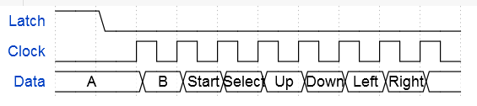
SNES controller uses a similar protocol but uses 12 out of 16 bits, being the last 4 bits at HIGH level (otherwise it is a different controller). Button A is present at the 9th bit so a double 8 bit reading shall return 0xFF,0x3F;

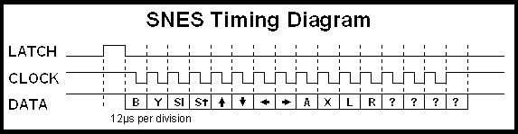
sdafs
sdf

Megadrive (Sega Genesis)
The Sega Genesis controller has some compatibility with ATARI controllers but even the regular 3 3 button controller have more buttons than wires available on DE-9 connector. To solve that problem the controller has one multiplexer that is commanded by one line (SELECT) coming from the console.

When that line is at HIGH level the controller shall read

And the other buttons are read with the line in LOW level.

The extra buttons on the 6 button controller are accessed by toggling the SELECT line three times in a row within a given interval
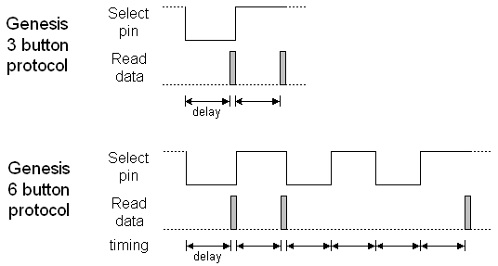
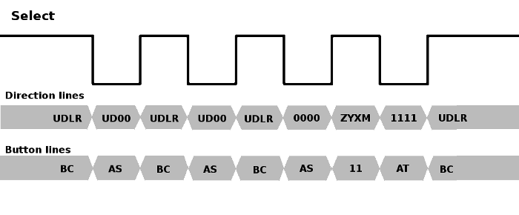
In Case of 3-Button-Controller

Sel D0 D1 D2 D3 D4 D5
Low UP DW LO LO A ST
High UP DW LF RG B C

# LO --- Always Low
# UP --- Up of Cross Key
# DW --- Down of Cross Key
# LF --- Left of Cross Key
# RG --- Right of Cross Key
# A ---- Trigger Button A
# B ---- Trigger Button B
# C ---- Trigger Button C
# ST --- Start Button
## Low -> Pressed , High -> Not Pressed

Data Aquisition Sequence of 6-Button-Controller

Sel D0 D1 D2 D3 D4 D5
Low UP DW LO LO A ST 0
High UP DW LF RG B C 1
Low UP DW LO LO A ST 2
High UP DW LF RG B C 3 # If there is two up-edge in 1.1 milli seconds,
Low LO LO LO LO A ST 4 # D0 - D3 go Low as Sel goes Low.
High Z Y X MD HI HI 5 # Make Sel High and read D0 - D3.
Low HI HI HI HI A ST 6 # Check that D0 - D3 go High as Sel goes Low.
High UP DW LF RG B C 7 # Once this sequence take place
Low UP DW LO LO A ST # sequence can't be started for 1.8 milli seconds
. # after the first up-edge of Sel.
. # Only Datas read in 1.6 milli seconds from the
. # first up-edge of Sel are reliable.

# LO --- Always Low
# HI --- Always High
# UP --- Up of Cross Key
# DW --- Down of Cross Key
# LF --- Left of Cross Key
# RG --- Right of Cross Key
# A ---- Trigger Button A
# B ---- Trigger Button B
# C ---- Trigger Button C
# X ---- Trigger Button X
# Y ---- Trigger Button Y
# Z ---- Trigger Button Z
# ST --- Start Button
# MD --- Mode Button
## Low -> Pressed , High -> Not Pressed

Mouse
// PS/2-mouse to MSX v1.1 //
// Made By: NYYRIKKI 2014 //

The Mouse sketch was slightly modified. The detection shall occur at powerup or by pressing the RESET button.
LEFT – MOUSE mode
RIGHT – JOYSTICK mode
LEFT+RIGHT – Mouse plus emulated joystick
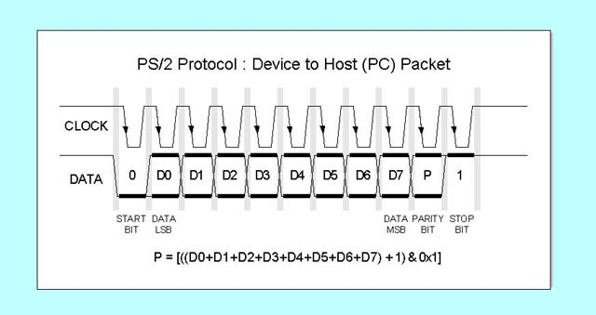
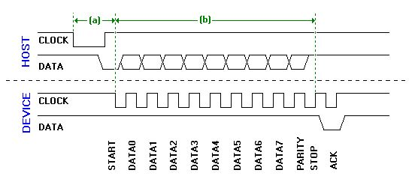

Dualshock
Based on
https://github.com/madsci1016/Arduino-PS2X

* Super amazing PS2 controller Arduino Library v1.4
* details and example sketch:
* http://www.billporter.info/?p=240

Gamecube
// Bit 7 6 5 4 3 2 1 0
//Byte 0 0 0 0 ST Y X B A
//Byte 1 1 L R Z Up Dw Rg Lf
//Byte 2 Joystick X Value (8 bit)
//Byte 3 Joystick Y Value (8 bit)
//Byte 4 C-Stick X Value (8 bit)
//Byte 5 C-Stick Y Value (8 bit)
//Byte 6 Left Button Value (8 bit) - may be 4-bit mode also?
//Byte 7 Right Button Value (8 bit) - may be 4-bit mode also?
a

OLED Display
https://github.com/greiman/SSD1306Ascii

